Soil and Landscape
Grid of Australia
Part of the digital information revolution for Australia’s landscapes

Fast facts
◆ A new approach to soil information is needed. Existing soil information
in Australia, while valuable, is incomplete and not focussed on soil function.
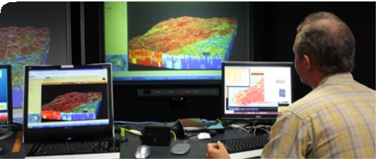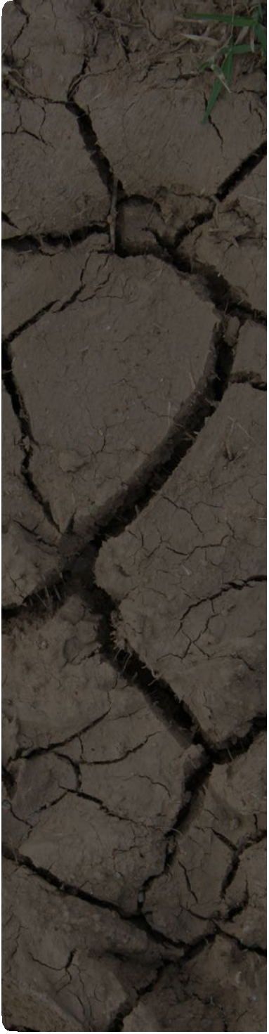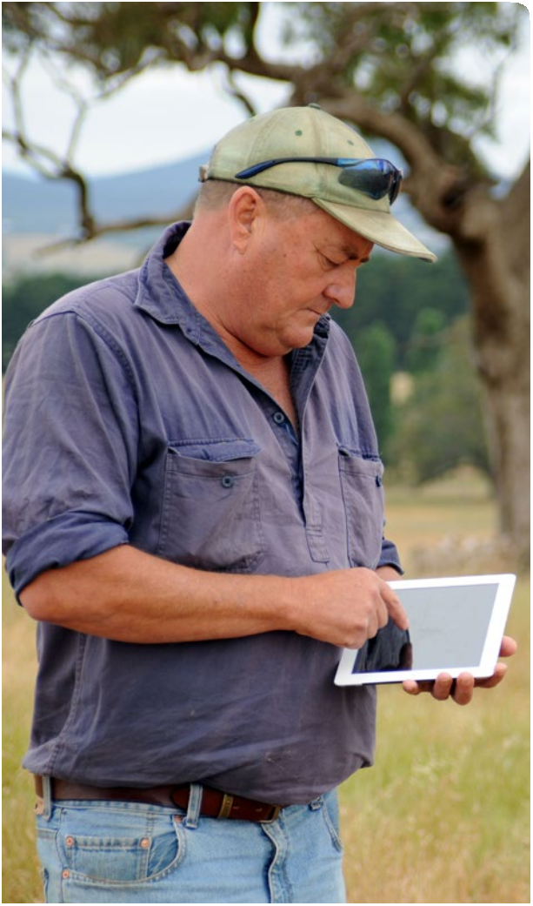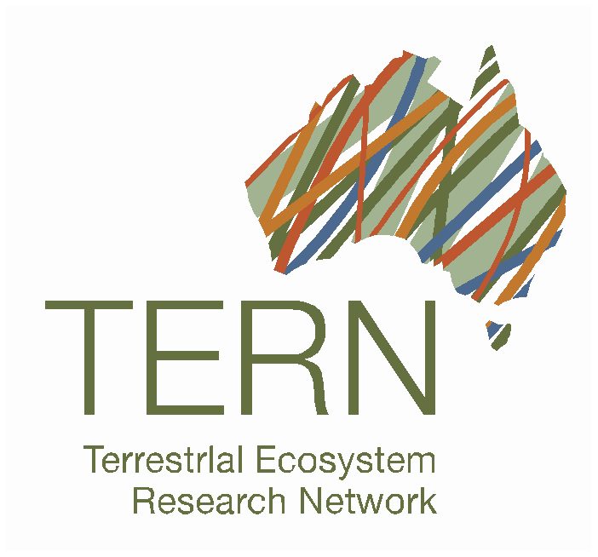New soil and landscape data infrastructure for the whole of Australia at the finest resolution ever – to support research, management
and policy.

Essential infrastructure: right soil and landscape information in the right form
The soil is a fundamental building block for life, essential for water, carbon, energy and nutrient cycles in ecosystems; and the soil itself is a complex and vital ecosystem.

Knowledge of Australia’s diverse soil and landscape attributes is crucial. By knowing
about the soil and landscape, land managers can ensure we have productive agriculture, protected biodiversity, effective water management and appropriate infrastructure development.

The Soil and Landscape Grid project has involved a huge collaborative effort across every state and territory of Australia with many organisations involved.

The Grid forms part of Australia’s new research infrastructure. The Grid provides easily-accessible, consistent, comprehensive and freely-available
soil attribute and landscape information. The Grid also provides estimates of uncertainty for each of the 90 x 90 metre pixels. Potential uses cover a range of spatial scales from continental down to regional and farm scales.

The data available in the Grid is not only for producing standalone policy-relevant products; it can be integrated with a wide range of
other databases and computer modelling programs. For example, the Grid has been designed to support agriculture, climate and ecosystem models.

Access the data at
www.csiro.au/Soil-and-landscape-grid
◆ The approach uses novel 3-dimensional spatial modelling combining rich historical data
with new digital information gathered through technology like satellites and
in-field sensors.
◆ The Grid provides approximately 2 billion data pixels and each pixel is 90 x 90 metre in size (roughly
the equivalent of a football field).
◆ Data on each soil attribute is available at 6 depth intervals
between 0 to 2 metres below the surface.
◆ Building of the Soil and Landscape Grid of Australia began in
2011 with Terrestrial Ecosystems Research Network support.
◆ The data in the Grid is consistent with GlobalSoilMap
project specifications and is part of the Australian Soil Resource Information System (ASRIS).
Products available
The Soil and Landscape Grid provides data on soil and landscape attributes with estimates of uncertainty. The data are consistent and comprehensive, in easily accessible raster file
formats that can be downloaded or viewed through an online portal.

Soil attributes:
◆ organic carbon content
◆ available water capacity
◆ clay content
◆ depth to rock
◆ depth of soil
◆ pH
◆ silt content
◆ sand content
◆ bulk density
◆ total nitrogen content
◆ total phosphorus content.

Landscape attributes:

◆ Solar radiation: depicts the amount of solar radiation hitting the surface of the earth.
This data is useful for assessing attributes like maximum photosynthesis potential, surface temperature and soil moisture accumulation.
◆ Multi-resolution Valley Bottom Flatness (MrVBF) dataset: a topographic index designed to identify areas of deposited material at a range of scales. This can be used, for example, in research
around fertility, erosion potential water flow and extent of aquifers.
◆ Slope, relief, curvature and topographic position:
provide landscape context which can be used
to understand landscape processes such as exposure to wind and rain, erosion and water and sediment movements.
◆ Topographic Wetness Index: used to calculate the accumulation of soil material and relative wetness within a catchment.
◆ Aspect: this data measures the direction the land surface slope faces, which can be used for calculations of moisture accumulation in soil profile and the thickness of soil.

collaborations and shared knowledge between:
◆ CSIRO
◆ Geoscience Australia
◆ NSW Office of Environment & Heritage
◆ Northern Territory Department of Land
Resource Management
◆ Queensland Department of Science, Information
Technology, Innovation and the Arts

◆ South Australia Department of Environment, Water and Natural Resources
◆ Tasmania Dept Primary Industries, Parks, Water and Environment
◆ The Australian Collaborative Land
Evaluation Program
◆ University of Sydney
◆ Victoria Department of Environment and
Primary Industries
◆ Western Australia Department of
Agriculture and Food.

About TERN
The Terrestrial Ecosystem Research Network (TERN) was established in July 2009 to spark a national collaborative effort to build the data and infrastructure needed to meet the needs of the terrestrial ecosystem research community.

The network also promotes terrestrial ecosystems science interactions and planning in Australia. TERN is supported by the Australian Government through the National Collaborative Research Infrastructure Strategy(NCRIS).

More information and related projects
Webpage: www.tern.org.au/Soil-and-Landscape- Grid-of-Australia-pg17731.html

GlobalSoilMap project in Oceania region:
www.oceaniasoil.net

SoilMapp app for iPad: www.csiro.au/soilmapp

Email: soilandlandscapegrid@csiro.au

Solar radiation in summer in the Adelaide Hills, South Australia, showing the variations in solar energy reaching the surface (due to topography)

Partners
Delivering the Soil and Landscape Grid of Australia has been made possible through longstanding
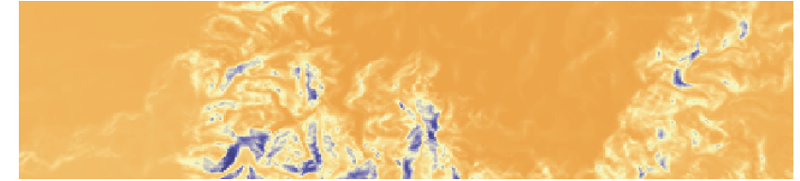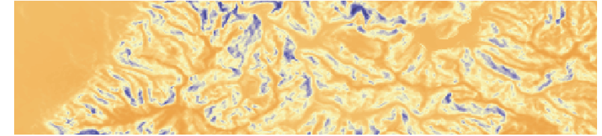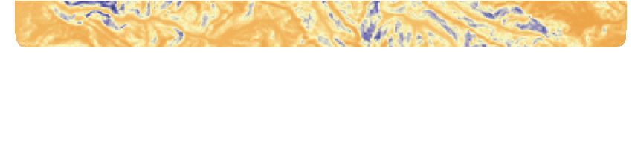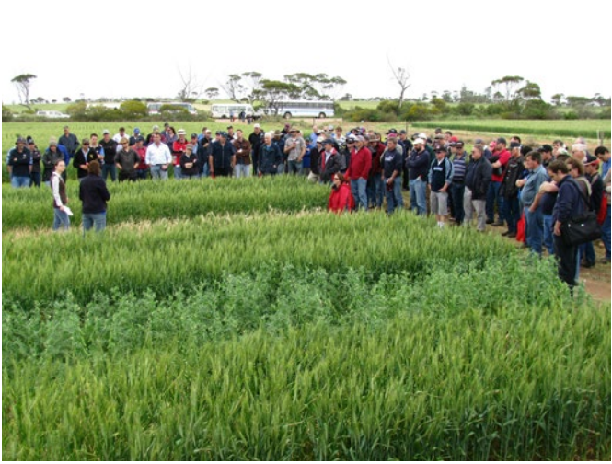

B&M | 14- 00657

